*News from around Australia*

***Tuesday 20th march 2012***

**Big Stories**

**Inside**

Community in shock. Homes destroyed. Survivors talk of their incredible escape.

**Interview with flood survivor Peter Maloney**

**Sport p34**

**Stock and share reports p9**

*EXCLUSIVE NEWS TODAY*

***ALL ABOUT THE BIG WORLD WE LIVE IN***

**Disaster cyclone in QLD**

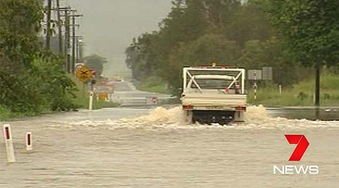

By Olivia Jackson

**Residents of far north Queensland have experienced a category 1 cyclone that has destroyed nearly the whole of the gulf of caparnteria. The cyclone hit at 8.30am on Tuesday the 20th of March 2012. It was formed by very low air pressure.**

**Residents were being warned to evacuate fleetly, tightly tape up glass windows, pack lots of yummy food and first aid for the long journey of cyclone Mitchell**

**During the harsh cyclone there was 200mm of rainfall across the gulf 100km gust of wind in every direction houses were shaking trees were going crazy and windows were shattering.**

**After the tremendous cyclone the houses were trashed and destroyed crop farmers were cleaning up their atrocious farms silo was down schools were flooded roads were destroyed.**

**The cyclone was formed by converging winds and low air pressure in the gulf of Carpentaria a tropical low in the states gulf country is causing heavy rains, gale force winds and flash floods across parts of north Queensland.**

*This is Queensland after the cyclone and floods.*

**Luckily there were no dead people 1 injured person who was found on the top of his Ute.**

**The repairing of cyclone was almost 6.2 billion dollars the government says this could take years to rebuild what has been destroyed. The communities around Australia have been creating fundraises for all the people who have been disadvantaged in the cyclone**

**Relief fund to be established for residents of North Queensland p3**