***Thursday April 2nd 2012***

*News from around Australia*

**The Argus**

**Inside**

Community in shock. Homes destroyed. Survivors talk of their incredible escape.

**Interview with flood survivor Peter Maloney**

**Sport p34**

**Stock and share reports p9**

*EXCLUSIVE NEWS TODAY*

***ALL ABOUT THE BIG WORLD WE LIVE IN***

**Cyclone Destroyer!!**

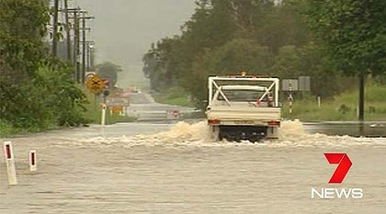

By Malekai Shead

**The residents of North Queensland have to fear the worst of a category one cyclone coming. The people are calling it Cyclone Mitchell. It crossed the Gulf of Carpentaria. It is developed by a deep low air pressure.**

**67 houses have already been evacuated. Luckily no casualties have happened but cars and houses have been destroyed. You can also put tape on your windows.**

***Flash flooding in North Queensland***

**Several schools will be forced to shut because of the flooding. Trees and signs have also been blown down. A man was rescued on Sunday night from the roof of his ute. Since all the roads are closed they have to get food supplies delivered from helicopters and planes. This cyclone destroyed a lot of buildings and cars but no people were killed in this category one cyclone**

**This category one cyclone bringing gusts up to 100km/h. Mission Beach recorded 308 millimeters of rain with several small towns exceeding 200mm from 9am yesterday.**

**Relief fund to be established for residents of North Queensland p3**