**The Red Telegraph**

*News from around Australia*

***Tuesday 20th March, 2012***

**Inside**

Community in great shock. Homes destroyed. Survivors made homeless.

**Interview with flood survivor Peter Maloney**

**Sport p34**

**Stock and share reports p9**

*VERY EXCLUSIVE NEWS TODAY*

***ALL ABOUT THE BIG WORLD WE LIVE IN***

**Cyclone Mitchell Attacks**

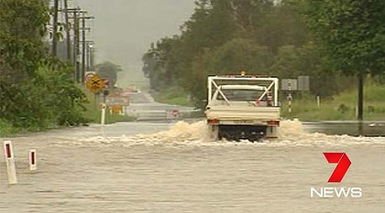

By Orlena Maxwell

**The people of North Queensland are shocked because Cyclone Mitchell attacked Gulf of Carpentaria on the 20th March. Cyclone Mitchell developed from a deep low pressure system and attacked early Tuesday morning.**

**67 houses have been evacuated because of the flash flooding. They were not prepared for it properly but next time they will be because now they know that taping your windows are safer and to build a stronger house. The state emergency people have advised people to pack food and drinks for a week.**

**Some houses have been flooded while others had their roofs blown off, leaving some of the people homeless. 7 schools in Giru have been closed. Some roads were closed which makes food supplies hard to get. That means the food needs to be delivered by helicopter or plane.**

**There was more than 200mm of rain at some places. A 2.5m croc was spotted. The winds on Cyclone Mitchell reached up to 110k/h. That classified the cyclone as a category 1.**

***Flash flooding made road closed.***

**Cyclone Mitchell was formed because of the deep low pressure. Also by the converging winds and with the help of the warm ocean waters.**

**The Queensland fire and rescue service has sent two swift water rescue teams to help the people. People can donate money to help the homeless have homes.**

**Relief fund to be established for residents of North Queensland**