*News from around Australia*

***Monday 19hMarch, 2012***

**The Argus**

**Inside**

Community in shock. Homes destroyed. Survivors talk of their incredible escape.

**Interview with flood survivor Peter Maloney**

**Sport p34**

**Stock and share reports p9**

*EXCLUSIVE NEWS TODAY*

***ALL ABOUT THE BIG WORLD WE LIVE IN***

**CYCLONE MITCHELL IS HERE**

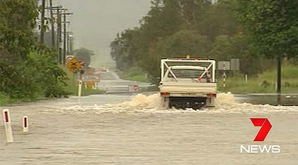

BY Tim McVerry

**Residents of North Queensland are expecting a dreadful cyclone called Cyclone Mitchell that will hit on the 20th of March 2012 (Tuesday). It was developed by a low pressure system in the Gulf of Carpentaria.**

**State emergency services say that 67 houses have been inundated and evacuated over night and you should pack food and medical supplies. You shoud put tape on your windows and tie down anything out side.**

***Flash flooding in north Queensland.***

**Cyclone Mitchell is a catagory 1 with wind speeds up to 100km/ph that tore up vegitation, ripped roofs from houses, tore signs out of the ground and shut down schools.**

**Relief fund to be established for residents of North Queensland p3**