*News from around the corner and around the world*

***Tuesday 20th March 2012***

**The Telegraph**

**Inside**

Community in shock. Homes destroyed. Survivors talk of their incredible escape.

**Interview with flood survivor Peter Maloney**

**Sport p34**

**Stock and share reports p9**

*EXCLUSIVE NEWS TODAY*

***ALL ABOUT THE BIG WORLD WE LIVE IN***

**Take cover Mitch is coming**

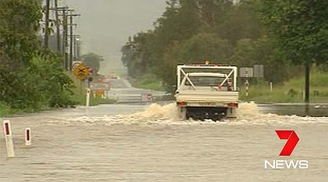

By Madi Morgan

**On Monday 19th March 2012, the residents of far North Queensland knew what was coming up. At 8:24 category 1 Cyclone Mitch hit the areas of the Gulf of Carpentaria.**

**Residents have been told to prepare and evacuate for the cyclone. They’ve been told by local police to pack food, water, clothes and medical supplies. Tape up there windows, tie up their boats and then to evacuate to the nearest evacuation center.**

**Cyclone Mitch did a lot of damage to the areas of North Queensland.**

**Approx $6.2 billion was and is being spent on the damage. Lots of beautiful trees were destroyed by the harsh winds, vegetation was flattened and signage was lost. Lots of boats have been tossed and left crushed in the docks of Queensland. More than 200 houses and buildings have been blown down and lots of cars flipped in the winds.**

**Mitch bought wind speeds of up to 100km ph, the winds and the heavy rainfall overnight have battered parts of a monsoon through extending from the Gulf north tropical Coast.**

***Townsville, after the foods and cyclone****.*

**Mitch bought wind speeds of up to 100km ph, the winds and the heavy rainfall overnight have battered parts of a monsoon through extending from the Gulf north tropical Coast.**

**Because of the severe weather, several schools in Normanton and Kurumba have closed and have been re-opened today. Mission beach recorded 308mm of rain with some small towns exceeding 200mm from 9 am yesterday.**

**Cyclone Mitch was formed by a very low pressure system making it obviously a category 1 cyclone. After the monster Mitch hit the Queensland fire and rescue services sent out two swift speed boats to Mount Isa and Townsville to help people recover from this crisis.**

**Relief fund to be established for residents of far North Queensland p3**